Diablo (1996, PC), Blizzard. GAMEPLAY – INVENTORY OPEN

1. Composition
Tangible space | In this specific configuration, tangible space occupies a little more than one third of the screen, and feels like it may extend to less tangible objects (see notes).
Intangible space | Intangible space is scattered around the screen, but clearly out of the tangible space.
Negative space | Heavily ornamented, patching every pixel that has no ergodic value. Intangible icons and menus are soaked in its mimetism.
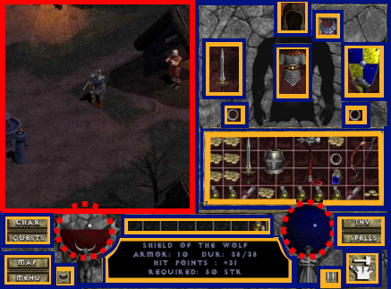
External | Zero Ergodic
2. Ocularization (tangible space)

3. Framing mechanisms | Anchor : Subjective | Mobility : Connected

4. Plane Analysis
 | Agents | In-game | Off-game
Graphical materials | Pre-rendered 3D | Pre-rendered 3D | None (intangible space)
Projection method | Axonometric | Axonometric | None (intangible space)
Angle of projection | ¾ View | ¾ View | None (intangible space)

Notes:
Interesting and more complex to describe than to play, the hack n’ slash genre blends tangible fast-paced action and a quite external managerial stance. Diablo makes heavy use of mimetic ornaments in what seems like an attempt to inject tangibility into the game interface. Although part of the intangible space, Mana and Health update in real time and are very ostentatious before the player’s attention, creating some sort of cognitive continuity from the immediate action to the more intangible menus (that are arguably more mimetic than the tangible space). The game affords an assessment of tangibility on a spectrum, instead of a binary distinction. Moreover, reinforcing the weight of intangible information, the visual space is saturated with mimetic icons. Represented items require selection to display text information, giving inventory management an almost tactile quality (unlike 1990’s JRPG menus).
